Page 1 of 3

Sample Form for Providing CHEMTREC with Information Regarding Shipments of Low Level Radioactive Materials

Shipper: ABC Shipper

Product Shipped: Radioactive Material, Type A Package, 7, UN2915

No. of Packages | Basic Description | Label | Transport Index | Form | Radionuclide | Activity
1 | Radioactive Material,  Type A package,  UN 2915 | Yellow II | 0.1 | Normal, sealed source,  solid metal strip approx. 19 cm long | Am-241 | 27.75 MBq  (0.75 mCi)

Applicable 2008 ERG Guide Number: 163 (attached)

Other identifying or pertinent information:

Page 2 of 3

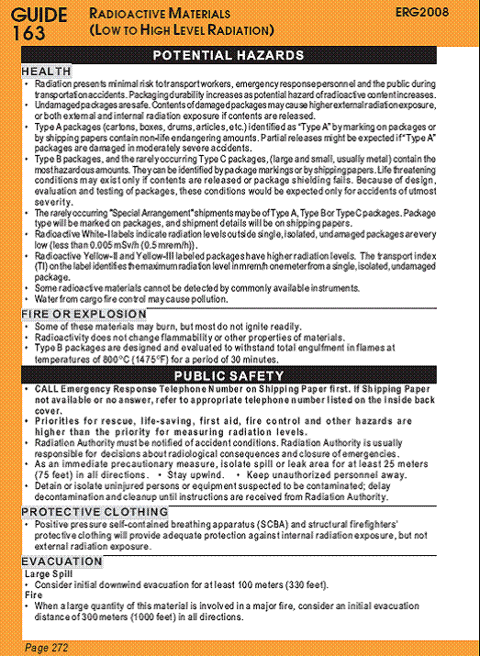

Page 3 of 3

